**Resume Management and Job Application Website with PHP, Bootstrap and MySQL**

Description

Feature

* Candidates are able to submit the form with their information.
* Candidates can attach CV on both .pdf and .doc files.
* Admin can manage all the resumes uploaded by the candidates.
* Admin can download the CV.
* Admin login to be able to enter to the system.
* Admin can create and update position which is automatically update on the Job Application website.

Online Resumes Management

Online Job Application

File structure

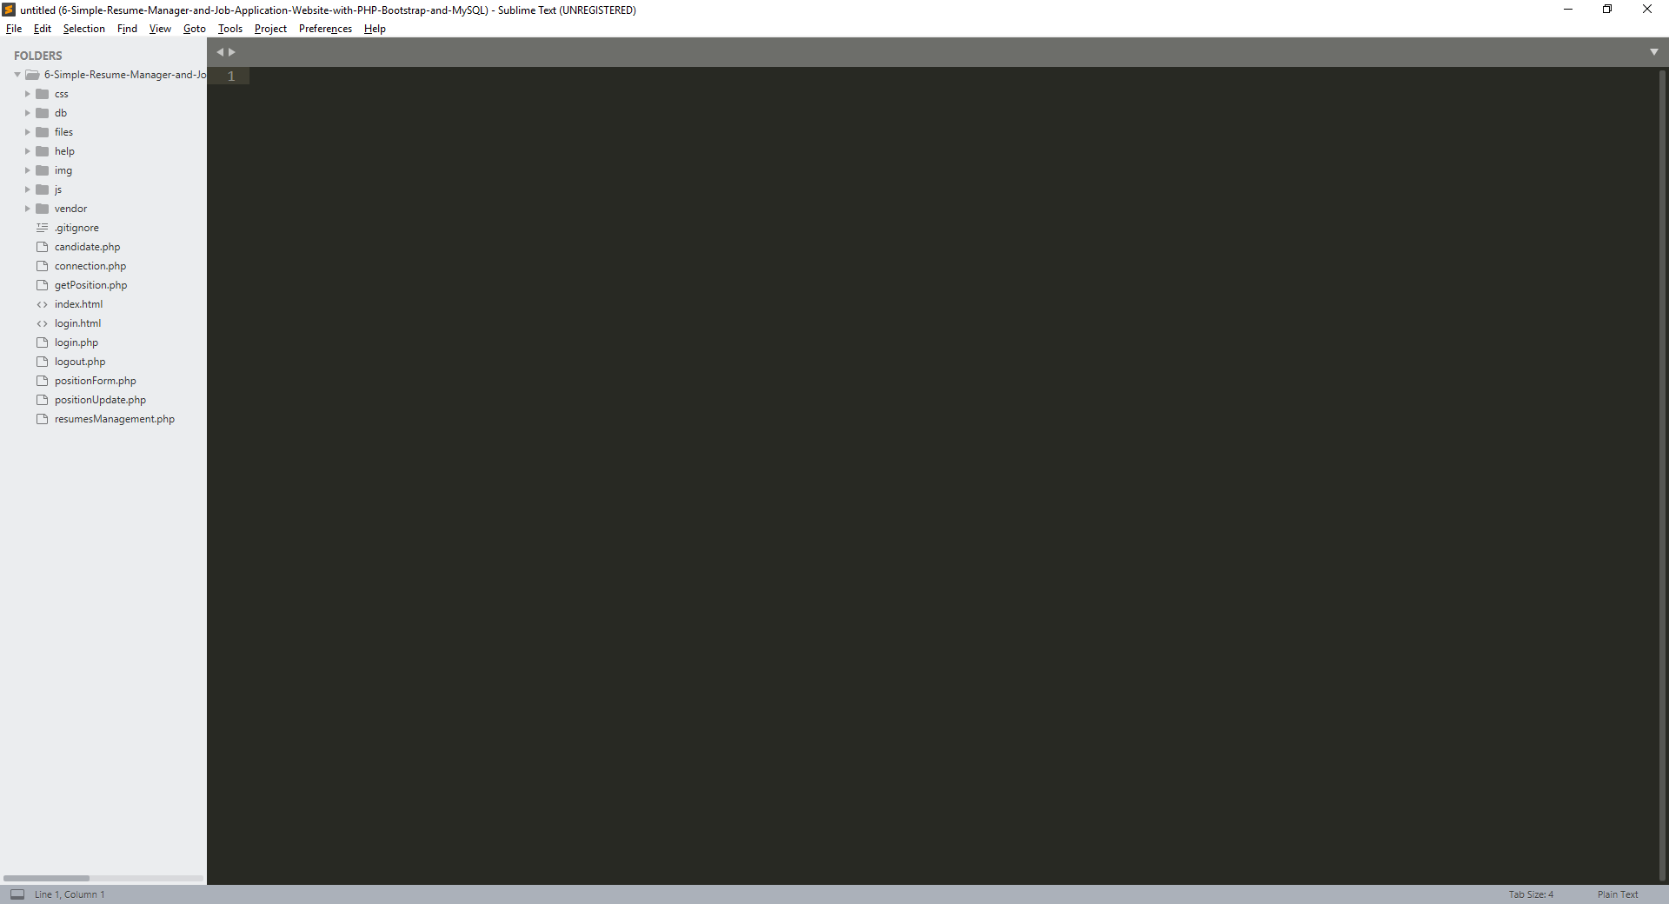

Database script

CREATE DATABASE egm_application;

USE egm_application;

CREATE TABLE `tbl_admin` (

`admin_id` int(11) NOT NULL AUTO_INCREMENT,

`admin_name` varchar(50) NOT NULL,

`admin_password` varchar(150) NOT NULL,

PRIMARY KEY(admin_id)

);

CREATE TABLE `tbl_candidate` (

`candidate_id` int(11) NOT NULL AUTO_INCREMENT,

`file_id` int(11) DEFAULT NULL,

`candidate_firstname` varchar(50) NOT NULL,

`candidate_lastname` varchar(50) NOT NULL,

`candidate_email` varchar(50) NOT NULL,

`candidate_phone` varchar(10) NOT NULL,

`candidate_address` varchar(100) NOT NULL,

`candidate_resume` varchar(50) NOT NULL,

`created_date` datetime NOT NULL,

PRIMARY KEY(candidate_id)

);

CREATE TABLE `tbl_file` (

`file_id` int(11) NOT NULL AUTO_INCREMENT,

`file_name` varchar(100) DEFAULT NULL,

`file_storage_path` varchar(100) DEFAULT NULL,

PRIMARY KEY(file_id)

);

CREATE TABLE `tbl_position` (

`position_id` int(11) NOT NULL AUTO_INCREMENT,

`position_name` varchar(50) NOT NULL,

`position_description` varchar(1000) NOT NULL,

`position_requirement` varchar(1000) NOT NULL,

`created_date` datetime NOT NULL,

PRIMARY KEY(position_id)

);

Resources

With hundreds if not thousands of resumes flowing in from job seekers it’s no surprise that resume management is a high priority for human resources and hiring managers. Recruiterbox has the tools to collect, parse, search, and manage resumes from your job seekers. Book your demo today to learn more about the powerful, [automated applicant tracking system](https://recruiterbox.com/features/candidate-sourcing-software/hr-recruitment-software) from Recruiterbox.

**Resume Extraction and Upload**

Upload resumes from a variety of sources and in all formats. With Recruiterbox, you can accept every resume file format from DOC and DOCX to RTF, HTML, and PDF. Skip the manual upload process and automatically collect resumes from your email attachments. [Don’t risk missing an emailed resume.](https://recruiterbox.com/comparisons/jazzhr-alternatives) Take the stress out of hiring with Recruiterbox.

## Easy Candidate Database Creation

Keep your hiring process organized with individual applicant profiles to collect and manage contact information, resume data, conversations, and more. The resume parser automatically extracts basic details while creating personal profiles. [Recruiterbox’s resume parser](https://recruiterbox.com/recruitment-software-features/parse-resumes) auto-fills their name, email, and phone number in the correct fields on their candidate profile. Avoid the headache of looking over dozens of documents with different layouts and fonts.

## Applicant Tracking and Search

With Recruiterbox’s candidate and resume search, easily pinpoint candidates with a single word or phrase. The [search feature](https://recruiterbox.com/recruitment-software-features/resume-search) combs through all text terms that appear in a candidate’s resume or the comments and messaging history on their profile. Don’t lose track of application question responses. Search for words that appear in written answers or filter by a specific multiple-choice selection. Find the candidates who meet your baseline requirements, so you proceed with the right people. Review previous hiring records to make improvements. Search through past candidates and filter specific reasons they weren’t hired. This may reveal ways to optimize future hiring.

## Why Choose Recruiterbox for Your Resume Management Software?

The features of Recruiterbox extend beyond just managing resumes and sorting them into stacks, but into all areas of the hiring process. Fast-growing businesses, whether small or medium-sized, can no longer sit still managing their resumes with old-fashion methods. They need an applicant tracking software that will handle the whole recruitment process in one place, instead of just managing resumes.

From job postings, careers site management, resume management, [applicant tracking](https://recruiterbox.com/features/career-site-management/employment-application-software), sourcing candidates, recruitment automation, interview scheduling, classified hiring, reports, and customized recruiting, you can’t go wrong with Recruiterbox. To reach the best talent, you need a strategic recruitment plan that will attract and evaluate the best candidates quickly, efficiently, and professionally.

## Boost Talent Acquisition

Give your talent acquisition a boost with an applicant tracking system solution featuring the following:

* **Careers Site Management** – manage your company’s website; customize the application and questionnaire forms, publish your openings, and customize your job openings with API key
* **Resume Management** – parse resumes automatically extracts data from applicants documents to create an applicant profile; download resumes from different sources
* **Applicant Tracking** – one glance tells you where a candidate is in the hiring process
* **Collaborative Recruiting** – simultaneously communicate with HR team members – leaving no one out of the loop
* **Sourcing Candidates** – job sharing with social media like LinkedIn, Twitter, Facebook, and Google; free search engine syndication with SimplyHired, Glassdoor, Indeed, ApplyIQ, and Recruit.net
* **Interview Scheduling** – save time with shared calendars, which allow for smooth coordination of interviews between candidate and HR members
* **Reporting Section** – EEOC reporting, applicant and source reporting, and more
* **Classified Hiring** – private conversations, private openings, and private fields

Recruiterbox is rated as one of the top ATS or recruitment software with features that will take your HR department or company to the next level. Sign up for your free live demo today.